Order Of Service

Singing: Psalm 42-43—CW page 82

Reading: Psalm 27

Opening Hymn: TLH 72

Reading: Revelation 9

Request Hymn: CW Supplement 750

Reading: John 6:60-71

Sermon Hymn: TLH 64

Sermon Text: Song Of Solomon 5:6

Mysterious Separation

Prayer

The Apostles’ Creed, TLH page 12

Holy Communion

The Lord's Prayer

The Blessing

Closing Hymn: TLH 68

* * * * * * * * * * *

Bible Study: Lambs: Romans 14:11; Every Knee Shall Bow
Sheep: Proverbs 12:1-7


Night Search

Water
Of
Life

18 December 2016

W A T E R O F L I F E

Independent Christian Church—Conservative Lutheran Doctrine

Worship Service: 9:30 a.m. Bible Study: 10:45 a.m.

Larry Cooper, Pastor E-Mail address:
111 N. Ridge Road lcooper@wateroflife.cc
Coon Valley, WI 54623 Web Site:
Phone: (608) 452-2105 www.wateroflife.cc

* * * * * * * * * * * * * * * * * * * * * * * * * * *

Sermon Text: Song Of Solomon 5:6

Mysterious Separation

* * * * * * * * * * * * * * * * * * * * * * * * * * *

Song Of Solomon 5:6 I opened to my beloved; but my beloved had withdrawn himself, and was gone: my soul failed when he spake: I sought him, but I could not find him; I called him, but he gave me no answer.

To set the scene: The Bridegroom is standing outside. His head being filled with dew and his locks with the drops of the night. He knocks at the door, saying to his Bride—“Open to me!”

After some hesitation the Bride, who was sleeping on her bed, at length arose and made her way to the door. In her own words: “I rose up to open to my beloved.”

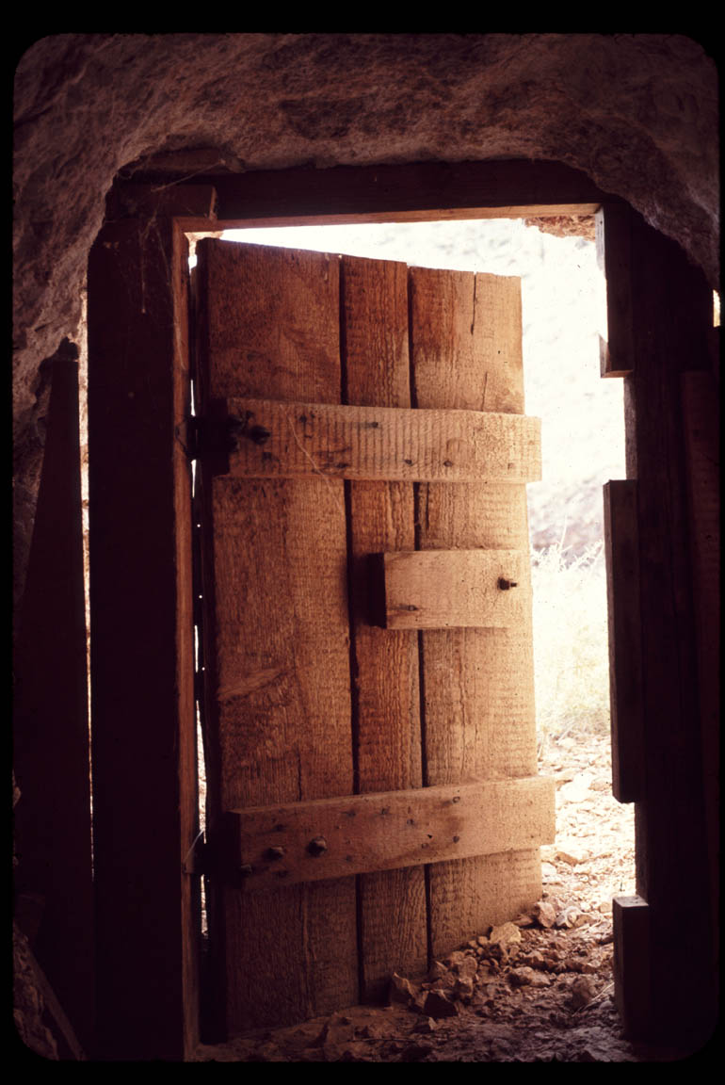

But then comes the shocker: “I opened to my beloved; but my beloved had withdrawn himself.”

The Bridegroom was gone! His Bride sought for him; but she could not find him. She called for him; but he did not answer.

And so we have a mysterious separation.

